PLAN, BUILD, EDIT, PUBLISH with Class Section Scheduler (CLSS)

Accessing CLSS
1. Log on to:
https://nextcatalog.unk.edu/wen/
2. Enter your username (email address that appears before the @ sign - louieloper@unk.edu)
Easi Password

Plan the course offerings
1. Click on a future “instance” or term to view all available “scheduling units” or departments
2. Click on any scheduling unit to view a list of all courses with all sections for that semester
3. Export the instance to Excel to plan changes.

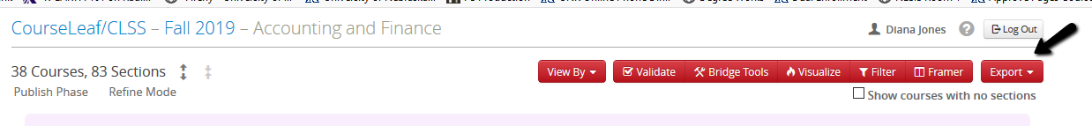

Build Phase
Most of the rules built into the scheduling system are turn off during the phase to allow the most flexibility to edit and create sections. The rules built within CLSS tighten in the Edit phase which requires multiple levels of workflow approvals.

1. Click on a future “instance” or term to view all available “scheduling units” or departments
2. Click on any scheduling unit to view a list of all courses with all sections for that semester
3. Double-click on the course to open and see list of any existing sections of the course.

Check “show courses with no sections” to include all courses in the course catalog, including those without sections for the semester. This box must be checked t view newly created courses which have not yet had a section created courses have not yet had a section created.
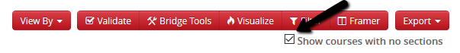

4. Double-click on the course to open and see list of existing sections of the course

To view All sections and Combined Sections
Click on the double arrows to “expand all” and see all sections in the scheduling unit at one time including combined sections
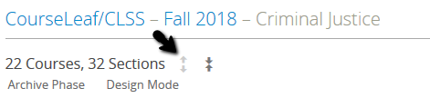

Editing Existing Sections
- Locate the course in your scheduling unit
- Double click on the course or “expand All” to open all courses.
- Open the section to be edit and edit the fields with the appropriate information.

Creating New Sections
- Locate the course in your scheduling unit
- If no section of this course currently exists for this term, check the box to “show courses with no sections
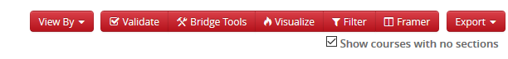
- Double click on the course or “expand All” to open all courses. A green circle with a white plus sign on the right side of the screen will appear.
- Hover the mouse over the icon to see “Add a section”
- Click on the icon associate with the course to open the Schedule Editor box
- “Create Section” Schedule Editor box opens to create the section.
- Fill in the fields with the appropriate information

Consider these questions-
When creating an arranged section for one student - do you want the student to register with a permit? If yes, indicate consent required.
Do you want to “hide’ the class number from other students? If yes, set Schedule Print to “NO” and provide class number to student via email once section is created.

Creating a Combined Section Relationship – “Combined With” Field
Think of this as a parent/child relationship. The courses are taught together with the same (or similar) title, with the same credit hours, in the same room, at the same time, with the same instructor.
Parent = 4XX course – cannot create or remove themselves from a combined section
Child = Honors section XXXH and/or 8XXP course – must create the combined section with the parent and must remove themselves from the combined section

Combining Sections
- Create or edit the existing Parent Course
- Create or edit the existing Child Course
- From the Child section, locate the “combined with” field
- Click on the arrow next to “combined with” and enter the subject, select the appropriate section from the list
- Enrollment Maximum field – enter the number of seats for this child section only
- Save

Rules for Combined Sections once the courses are combined:
Parent (4XX course) controls for all sections:
Meeting patterns
Room Assignment
Instructors
Combined Max Enrollment

Parent and Child each control separately:
Max Enrollment
Credit Hours
Status (open, stop further enrollment)

A pink bar will appear at the top of the screen indicating which section is the parent section

Ending a Combined Section relationship
Either the Parent or Child may decide to end the relationship. Usually, the Parent (4XX) decides to end the relationship BUT Only the Child (XXXH/8XXP) has the ability to actually to do this.
- Open the Child Section (XXXH/8XXP)
- Use the red X next to the parent section shown in the “Combined With” field to delete the entry

Link To
“Sibling sections” can be connected or “linked” for registration. For example: Biology 103 may have 11 sections – some may be lecture and some may be lab – but all sections are Biology 103 and are therefore “siblings” that be linked for registration.

- Create Section 01 of the course (i.e. lecture)
- Create Section 02, 03, 04, etc. of the course (i.e. lab)
- Select an option:
Not Linked to other sections
Any Lecture Section – means the student can take any of the specified section types with this section. Usually on the lab component of a lecture/lab link
Specific Section Type – means the student must take one of a group of the specified sections type with this section. Usually on the lecture component of a lecture/lab link
Section Numbers individually – Usually on the lab component of a lecture/lab

Using the Snapper Screen
The Snapper is so named because when hovering over the time grid, the software will attempt to “snap” the section into a pre-defined, standard meeting time. The default view is all sections of the same course but other courses of interest can also be added.

Adding a section meeting time
- Hover over the calendar to see possible meeting times for the default meeting pattern
- To view all times available for a meeting patter, hover over the View All tool (small boxes in grid in the top toolbar).
- To view other possible patterns, click on Patterns dropdown and choose another pattern. Meeting patterns are listed by order of preference for the scheduling unit.
- To limit days to view, click on Days dropdown, then select or deselect days.
- Click a box to see the meeting time for that section. Continue hovering to view and choose other possible patterns. The red bar on the left of each column indicates when the selected primary instructor is already scheduled.
- Click Accept to set the meeting time.

How to propose a meeting pattern:
- In the Patterns dropdown, choose “User Defined”.
- In the Meeting Pattern Name text box at the bottom of the dropdown, enter the requested meeting pattern.
Meeting Patterns must be formatted as follows:
Day initial (MTWTHF) space start time (8:00am) dash (-) end time (9:05am).
MWF 8:00am-9:05am
When adding additional times per week, separate each one with a semi-colon (:) and space
MWF 8:00am-9:05am; TTH 8:00am-9:15am
- Click Add to place the pattern on the snapper. In most cases, proposing a user defined meeting pattern will trigger a request to enter workflow. Take notice of errors and warnings and take action as instructed.

How to propose a meeting pattern with multiple times/rooms/dates:
- Click the Meetings button to view the Multiple Meeting view box.
- Choose a meeting from the view box to view it in the snapper or click the plus icon to add a new meeting.
- Hover over the calendar to see possible meeting times for the default meeting pattern.
- To view all times available for a meeting pattern, hover over the View all tool (small boxes in grid in the top toolbar).
- To view other possible patterns, click the Patterns dropdown and choose another pattern. Patterns are listed by order of preference for the scheduling unit.
- To limit days to view, click the Days dropdown, then select or deselect days.
- Click a box to set the meeting time for the meeting. Continue hovering to view and choose other possible patterns. The red bar on the left of each column indicates when the selected primary instructor is already scheduled.
- Click the Meeting button again to view the Multiple Meeting view box.
- Click the pencil icon next to the meeting to edit, or click the trash icon to remove the meeting. The pattern field will be greyed out. Select “Accept” and edit the pattern through the snapper’s calendar view.
- Use the Meeting Details screen to edit the type, room or dates. Dates should be entered in the format
YYY-M-DD.
- Click Accept
- Click the “X” in the Meeting view box to hide the view box.
- Click Accept to set the meeting patterns.

Room Grid View
ALL face to face sections must have a classroom assignment. To Be Arranged (TBA) sections such as Directed Readings, Thesis, Internships, Independent Study, etc. should be assigned to the Department Office as a point of contact for students.

The Room button displays the snapper with a room grid. Each room allocated to the scheduling unit appears on the left.

The available meeting patterns for the section appear across the top. All sections in CLSS assigned to those allocated rooms appear in the grid.

The purple sections are those that have the same meeting pattern as the meeting pattern being requested.

Sections in red are those that overlap the requested meeting pattern in some way, but do not use the exact same meeting pattern.

